1. 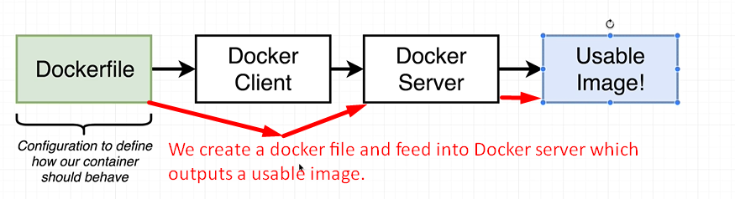
2. 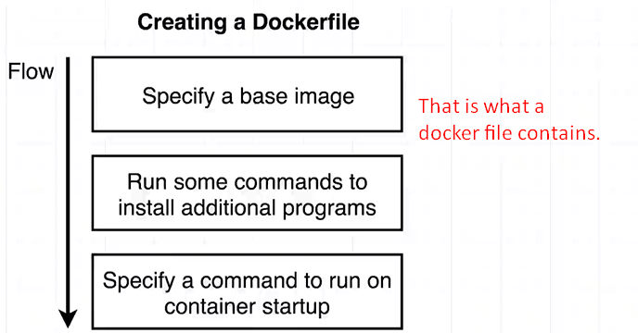
3. 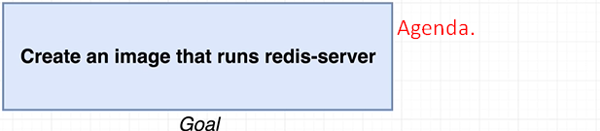
4. Let’s first create a project directory wherein we will do everything.
5. 
6. Cd into the directory  
   
7. Create a file named Docker without any extension and name is casesensitive.
8. 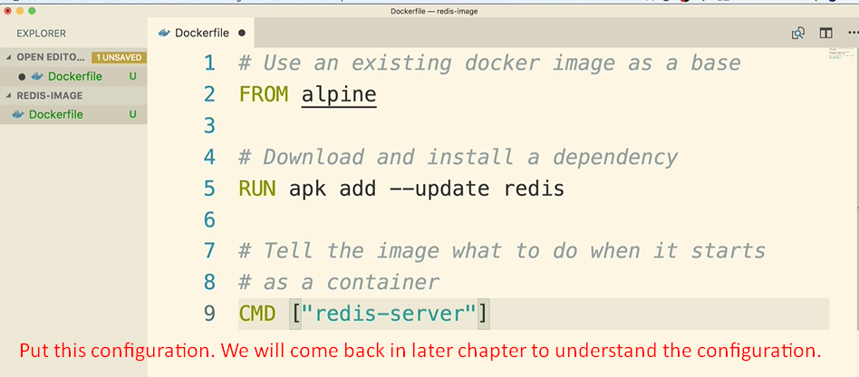
9. 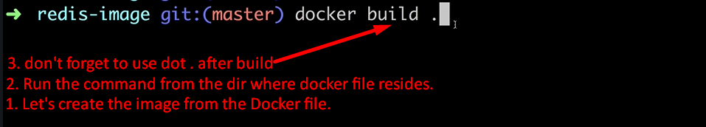
10. 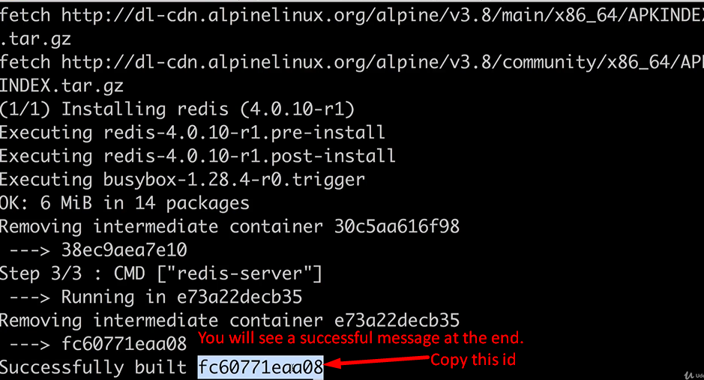
11. Now run docker run command with that id 🡺
12.  